

Table of Contents

**1.1 Open application** **1**

**1.2 Navigate to Cards screen** **2**

**1.3 Add a Card** **3**

**1.4 Search for Card** **4**

**1.5 Remove Card** **5**

**1.6 Add By Image** **7**

**2.1 Add Set** **10**

**2.2 Search Set** **11**

**3.1 Add Customer** **13**

**3.2 Search Customer** **15**

# 

# 1.1 Open application

(ALL USE CASES START ON THIS LAUNCH SCREEN AND THE FOLLOWING WELCOME SCREEN)

Press the **Open** button.

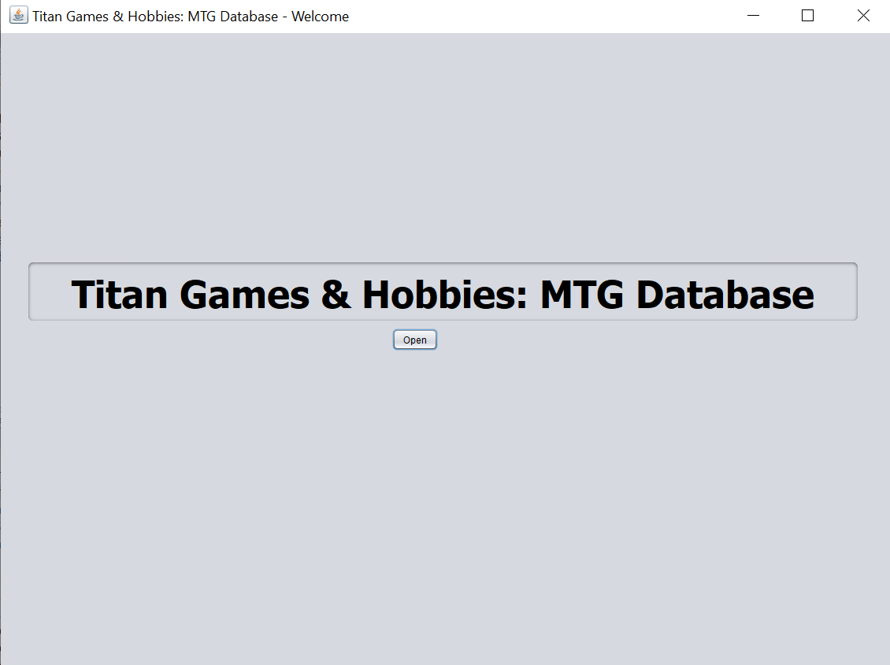

# 1.2 Navigate to Cards screen

Press the **Cards** button.

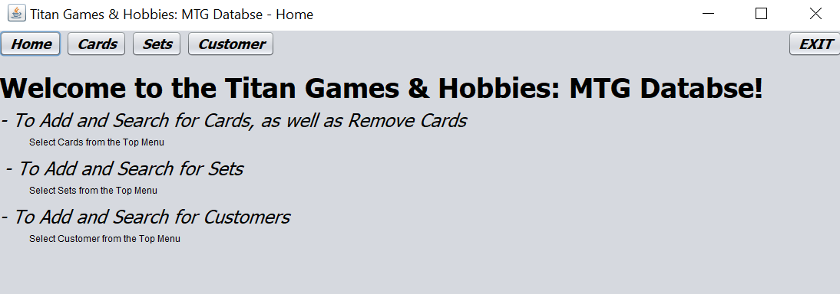

# 1.3 Add a Card

To add a card into the database fill in the applicable fields associated with the particular card.

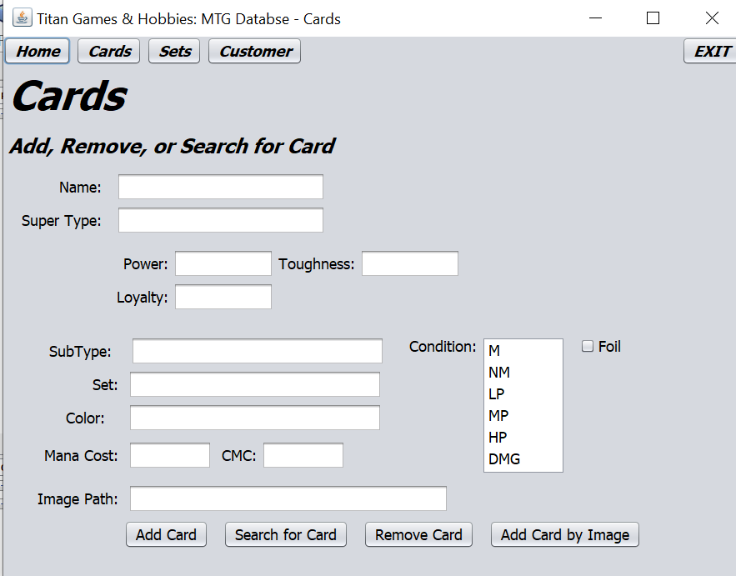

After all the fields are filled in the press the **Add Card** button to upload the card data into the database.



# 1.4 Search for Card

Enter the search criteria into the fields.



Press the **Search for Card**  button and the table would be displayed.



# 1.5 Remove Card

To remove a card type the name of the card into the card name field



Press Remove card.



# 1.6 Add By Image

Enter the card id into the image field.



Press the **Add Card by Image** button.





2- Sets

# 2.1 Add Set

Enter the set data into the set fields.

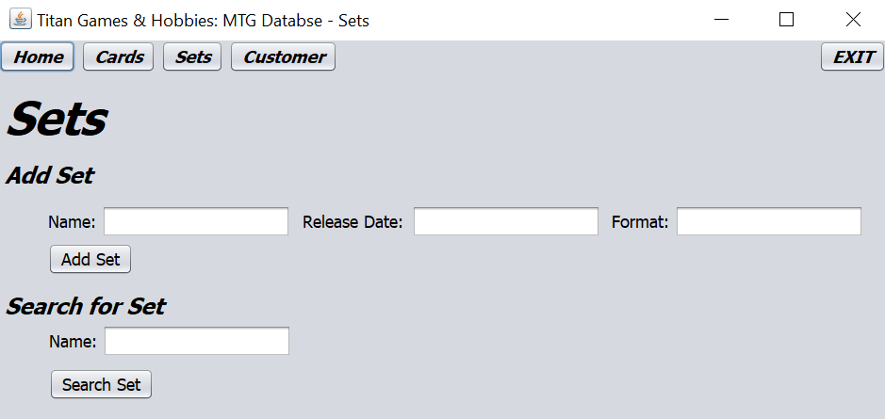

Press the **Add Set**  button.



# 2.2 Search Set

Enter the applicable fields for the search.



Press the **Search for Set**  button.



3 Customers

# 3.1 Add Customer

Enter the fields needed for the customer information.

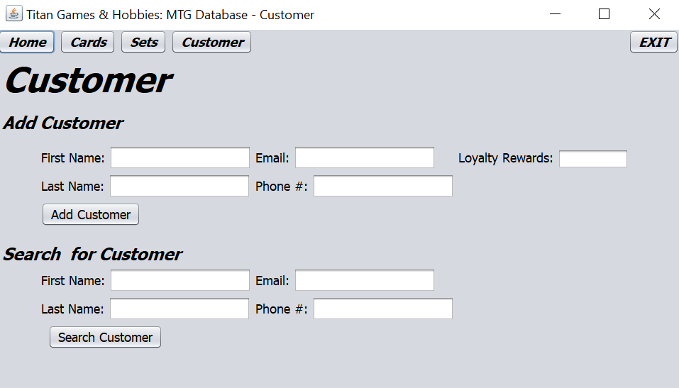

Press the **Add Customer** button

.



# 3.2 Search Customer

Enter the customer’s phone number into the fields.



Press the  **Search Customer**  button.



# 

# 

# 

# 

# 

# 